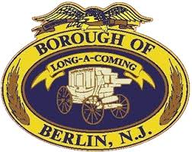
BOROUGH OF BERLIN
MUNICIPAL BUILDING
59 SOUTH WHITE HORSE PIKE
BERLIN, NJ 08009
WORKSHOP MINUTES
THURSDAY, OCTOBER 13, 2022 – 6:30 PM

CALL TO ORDER

ROLL CALL:
Councilman Len Badolato - Present
Councilwoman Patricia Cummings - Absent
Councilman Keith Hohing - Present
Councilman Jake Miller- Present
Councilman Andrew Simone - Present
Council President Jim Pearce - Present
Mayor Rick Miller - Absent

Also present: Solicitor, Howard Long
Co-Administrator, Bill Behnke
Deputy Municipal Clerk, Rachel von der Tann, CMR
Voorhees Municipal Clerk, Dee Ober, RMC

Council Discussion
Meeting was called to order by Council President Pearce.

Councilman Badolato stated that he had nothing new to report.

Councilman Simone stated that the street sweeper has not been delivered to date due to delays in parts being available. He added that neighboring towns have been helping with street sweeping. He stated that a new backhoe has been ordered.

Council President Pearce stated that his report would be given during executive session.

Councilman Miller stated that he was impressed with the festivities of the annual fire prevention night. He announced that he is working on bringing back the July 4th fireworks display and will have more to report at a future meeting.

Solicitor Long reviewed the agenda items with council. He stated in regards to the 2nd reading ordinance of the historical landmarks designations that referral was made to the Planning Board to review for consistency with the master plan.

